**How To Set Up Kingyan’s Settings Menu**

**(w/ Keybinds and Translations)**

***1- General Warnings and Notices***

**IMPORTANT, MOVE THE “RESOURCE” FOLDER OUT OF THE “KINGYAN” FOLDER.**

Most of the Graphics settings will not work properly if you use a scripted render pipeline (HDRP or LWRP for example). If you already have an Audio Mixer or a script that handles camera movement, you may need to tweak the code to have the volume, sensitivity and FOV sliders to work properly. To change the default values of each slider, you will have to look in the “SettingsMenuScript”, then in the “GetPlayerPrefs()” void, and change the values there. Every setting with an asterisk cannot be applied during runtime and requires the player to restart the game to see the changes. The settings are saved using PlayerPrefs, Changing

this will require a lot of complicated (and unnecessary) modifications to the code.

***2- How Translations Work***

The path of the translation text files are “Resources/I18n/”, you should name the files after the language (For example: en.txt, es.txt, pt.txt, de.txt, and so on).The fallback language is English, this means that if the script can’t find the system language it will automatically set the language to English.

Format: en.txt: es.txt:

=============== =================

|hello=Hello | |hello=Hola |

|world=World | |world=Mundo |

|... | |... |

=============== =================

For the text to be translated, you will need to add a “I18nTextTranslator” component if you are using Unity’s standard “Text” component or a “TMPTranslatableText” component if you are using TextMeshPro.

***3- General Layout of the UI***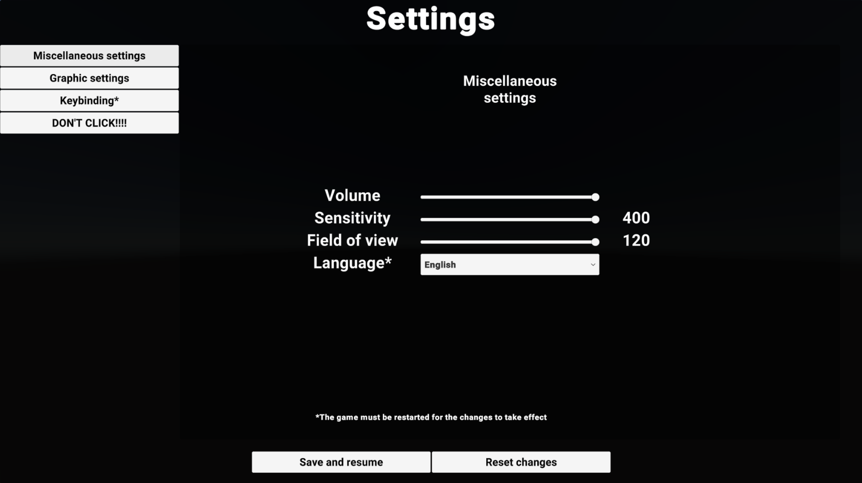

**This is the Miscellaneous Settings menu**, it contains a volume slider (which modifies an exposed parameter of an Audio Mixer that controls the volume), a sensitivity slider (which modifies the “mouseSensitivity” float in the “MouseLook” script), a FOV slider (which modifies the “FieldOfView” int in the standard “Camera” script that Unity provides), and a Language dropdown (which controls which text file the “I18n” script will read).

On the bottom of the screen, the “Save and resume” button will save the changes and close the settings menu, the “Reset changes” button will reload all the settings (but won’t delete any PlayerPrefs key)

On the left side of the screen, there are four buttons that allow the player to navigate between the different menus.

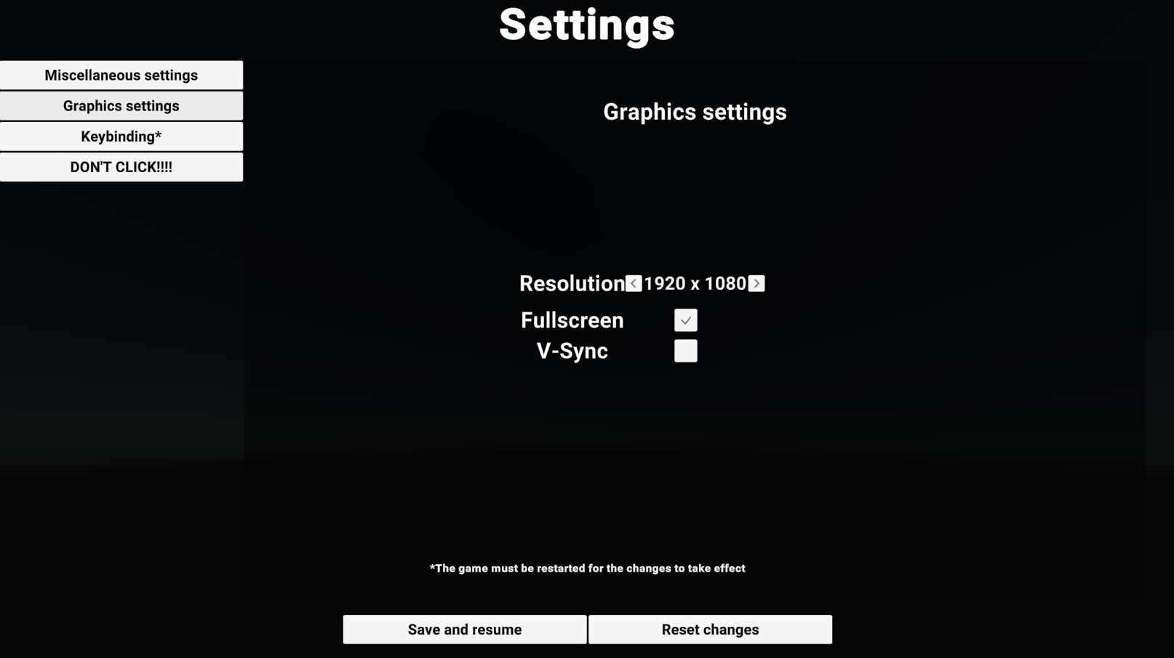

**This is the Graphics settings menu**, it contains a resolution selector (there are three resolutions in the preset but I’d recommend adding a few more), and fullscreen and v-sync toggles. As explained before in section 1, using a scripted render pipeline (such as LWRP or HDRP) will cause these settings to stop functioning properly.

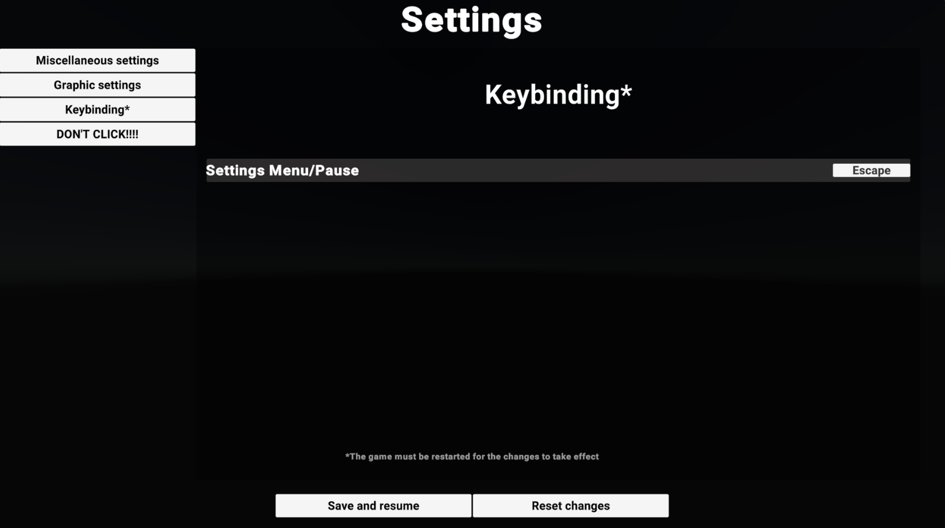

**This is the Keybinding menu**, there is only one setting in the preset but you can easily add more using the “KeyBindingButton” component. Warning: Keybinds are not affected by the “Save and resume” and “Reset changes” buttons.

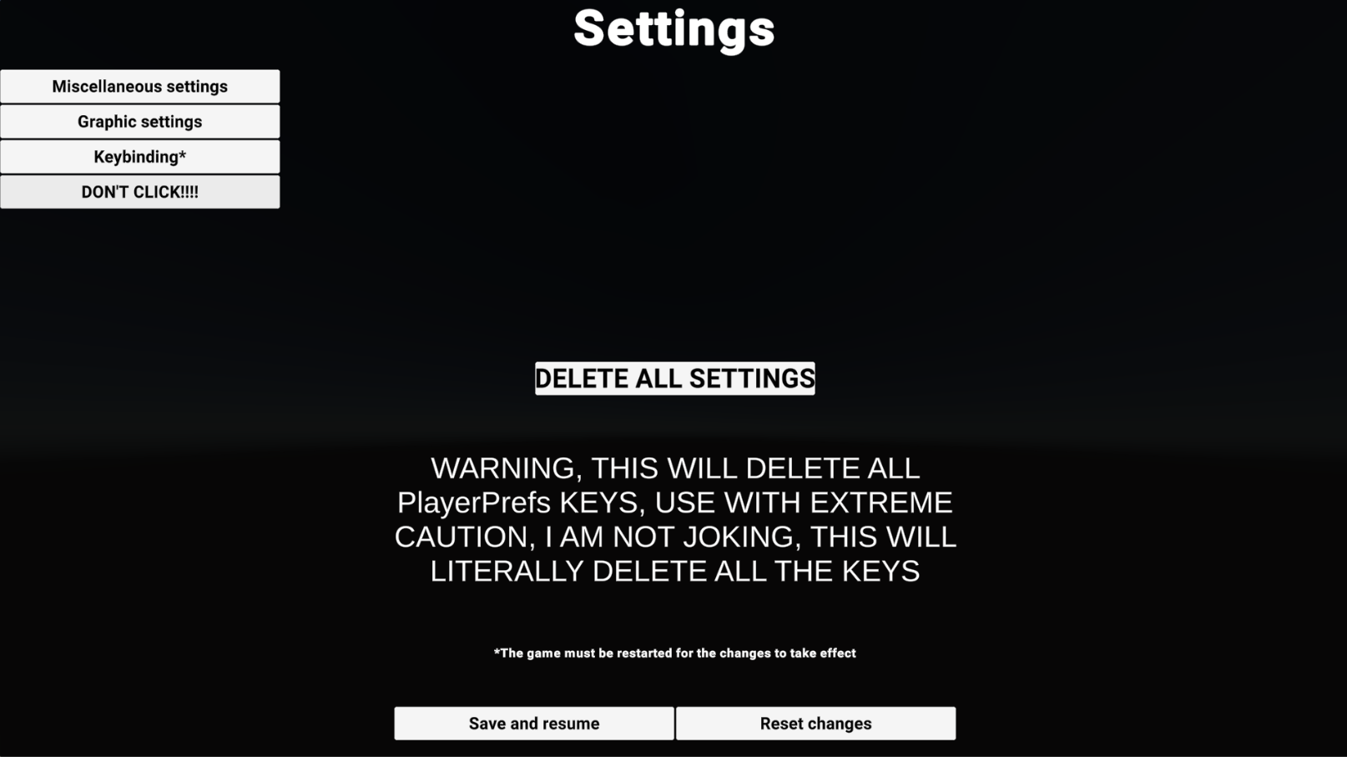

**This is the “DON’T CLICK” menu**, the “Delete all settings” button will delete every PlayerPrefs key, you should be careful around it.

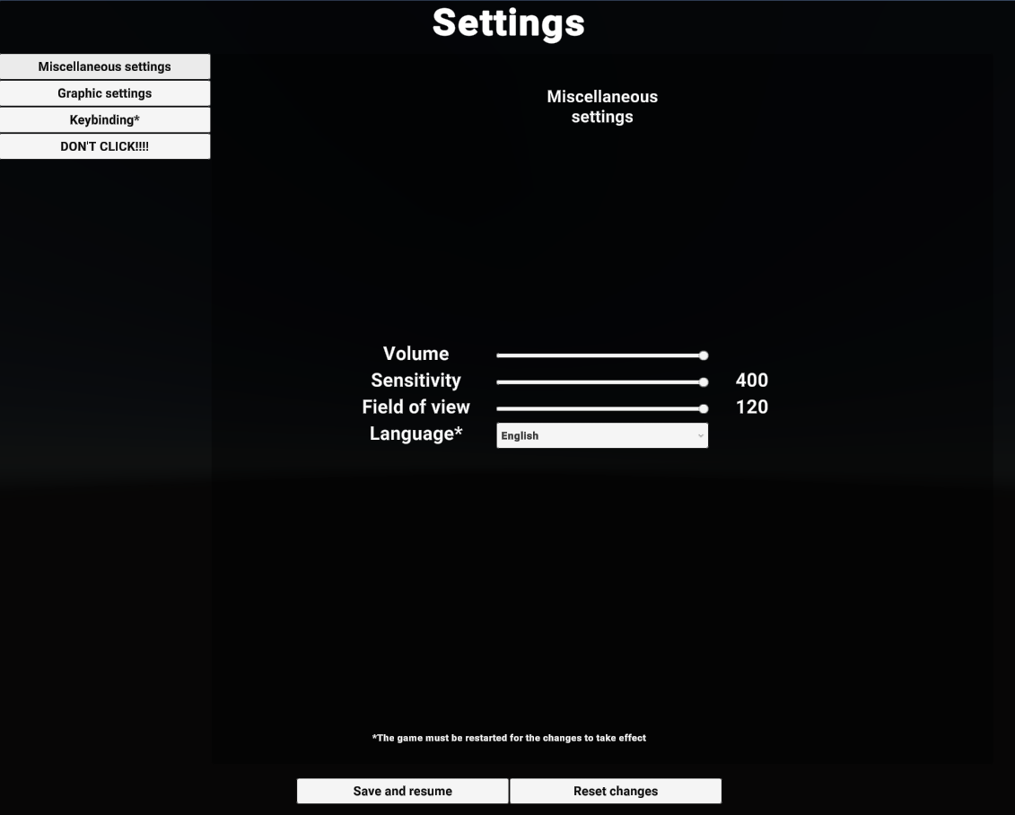

The UI will automatically resize to fit different aspect ratios, the UI has been tested and will work perfectly fine in 16:9, 16:10, 3:2, 4:3, and 5:4.